Sung-won Kim

300320693

Fall semester, 2020

CSIS-1280-004(Multimedia Web Development)

**Project Report**

**1.Title of the project :**

**Travel Together** (Travel Information Sharing Site)

**2.Brief description of the project**

1. Concept
   * The site shares good places to travel with children, destinations with themes such as movies and food, various memories of the place, and information on the travel routes.
2. Development focus

* The column layout of the topical sections of the pages should be arranged according to the data and responded to the resolution of the devices.

1. Development and reason in the three phases
   * Phase I : HTML coding & fill out contents that fits on the subject sections
   * Phase II : Separate contents data from HTML.
   * Phase III : Convert static HTML code to dynamic JAVA SCRIPT code
   * Reason : The reason why I developed this site in three stages is because I wanted to utilize what I learned in class as much as possible and implement it. Because of that, it took a lot of time, but I could learn a lot by using many things related to web development.

**3.Wireframe**

**1) Home Menu**

Desktop display (use minimum width: 320px and maximum width: 1200px)

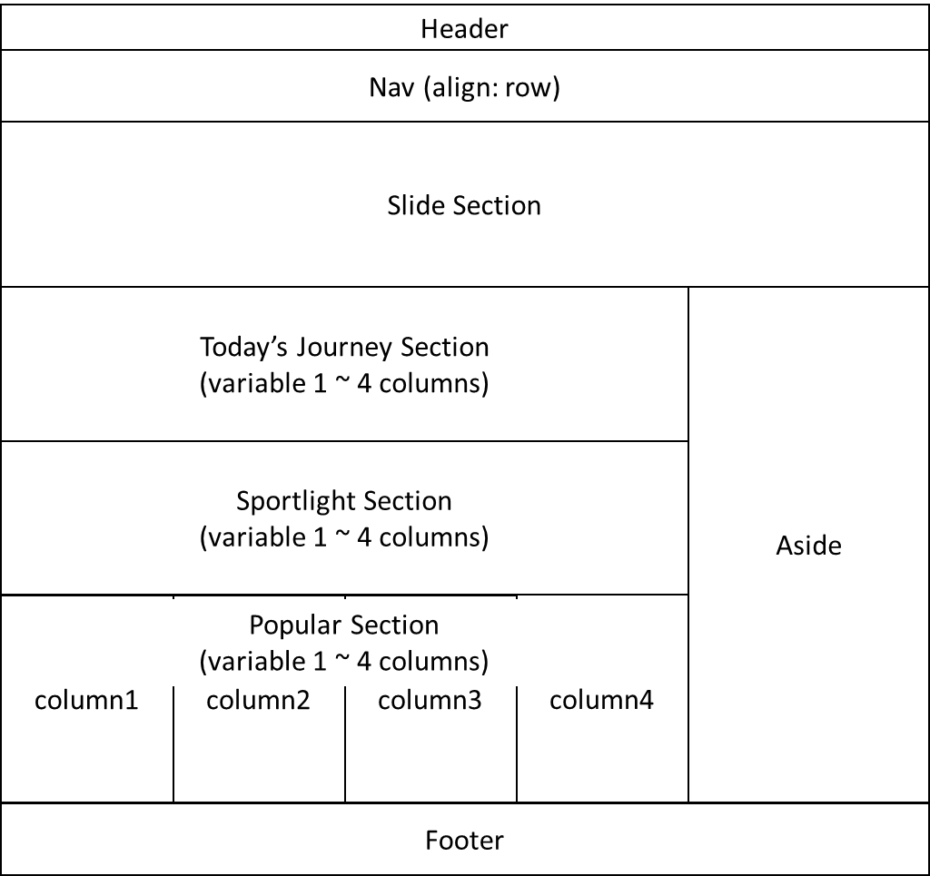

Tablet display (use minimum width: 320px and maximum width: 1024px

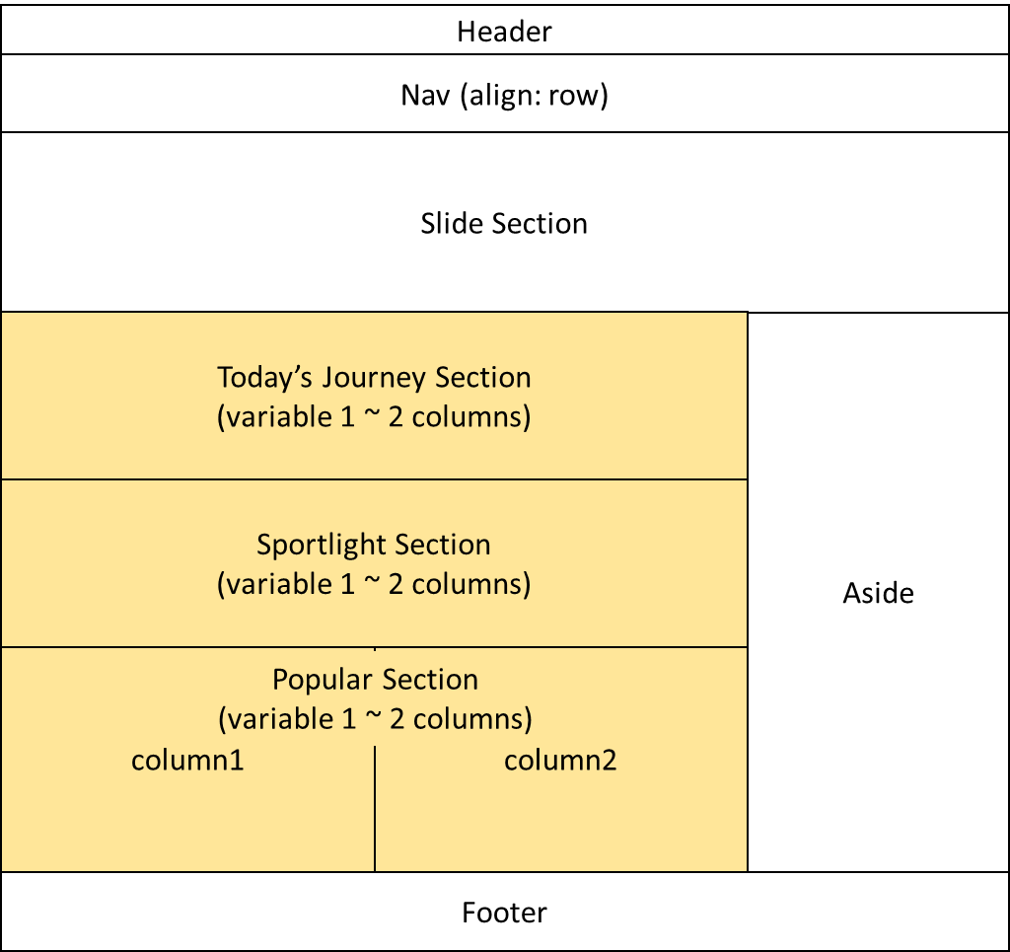

**2) Other Menu**

Desktop display (use minimum width: 320px and maximum width: 1200px)

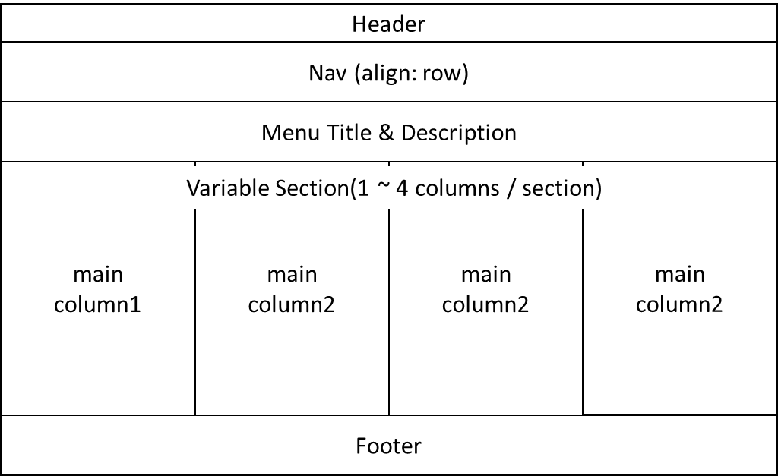

Tablet display (use minimum width: 320px and maximum width: 1024px)

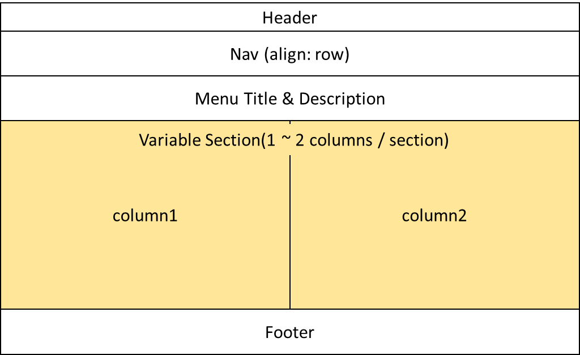

**3) Both common point**

Mobile display (use minimum width: 320px and maximum width: 768px)



**4.Sitemap**

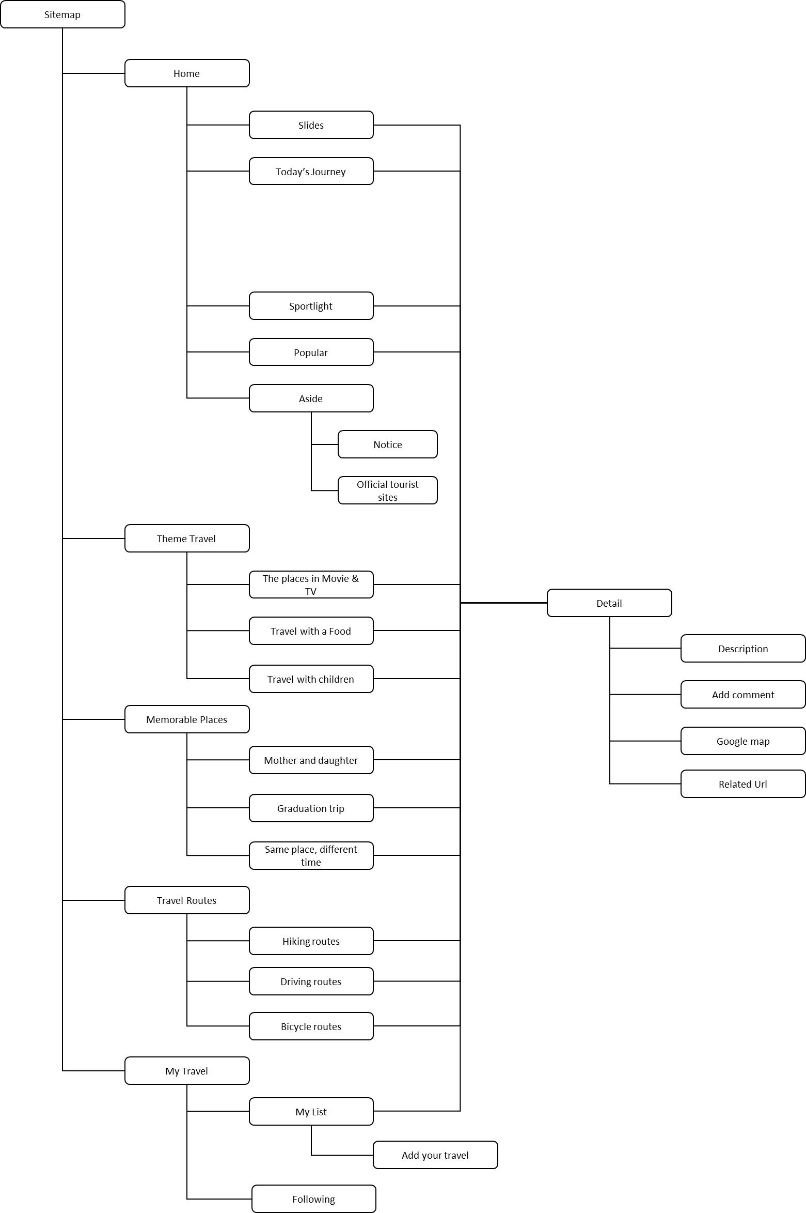

**5.Structure of each page**

1. **Common things**

* HTML Page contents are dynamically generated by the Java script code, CSS, and predefined array data.

[ Java script code ] [CSS] [Data]

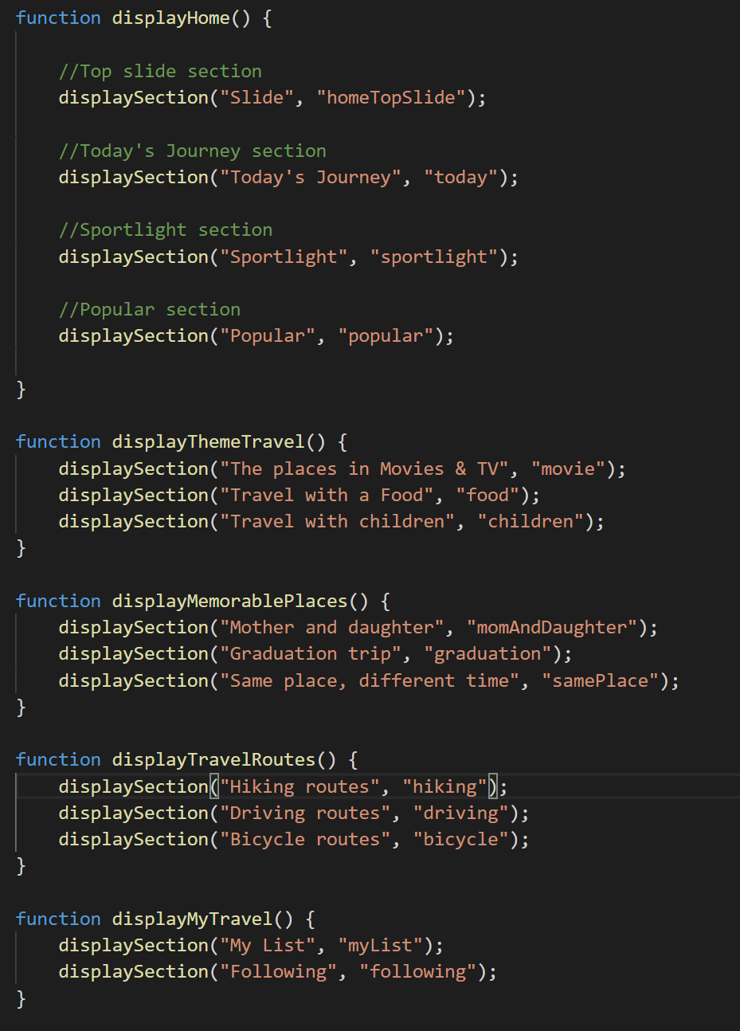 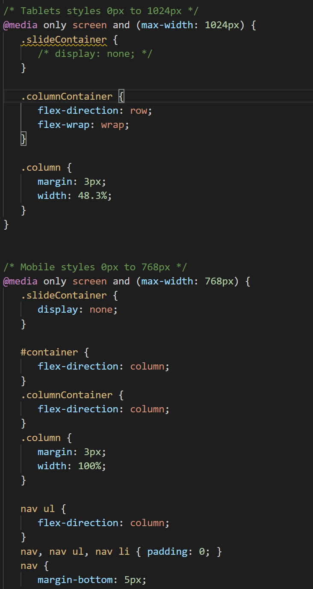 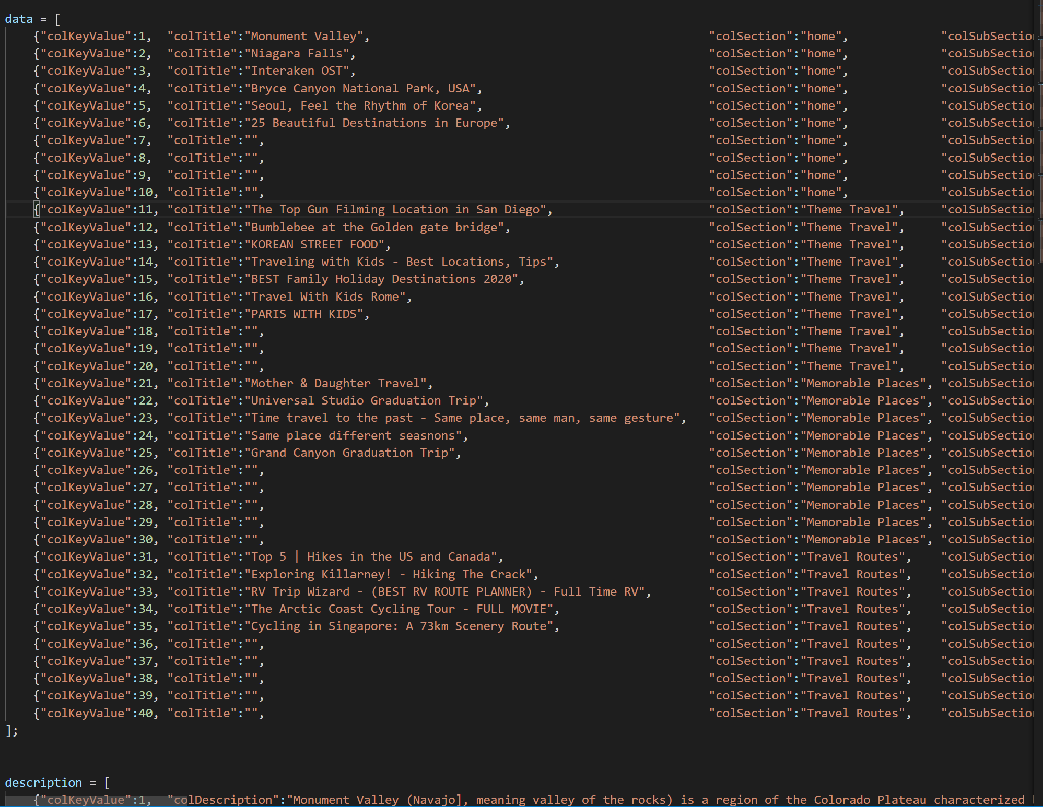

* Creating pages by defining the section id of HTML and invoking the section function.
  + Reactive design: Change page layout according to screen resolution (Tablet, Mobile)
    - **Desktop mode**

- One to four columns in the main section are variable.

[Home] [Other menu]

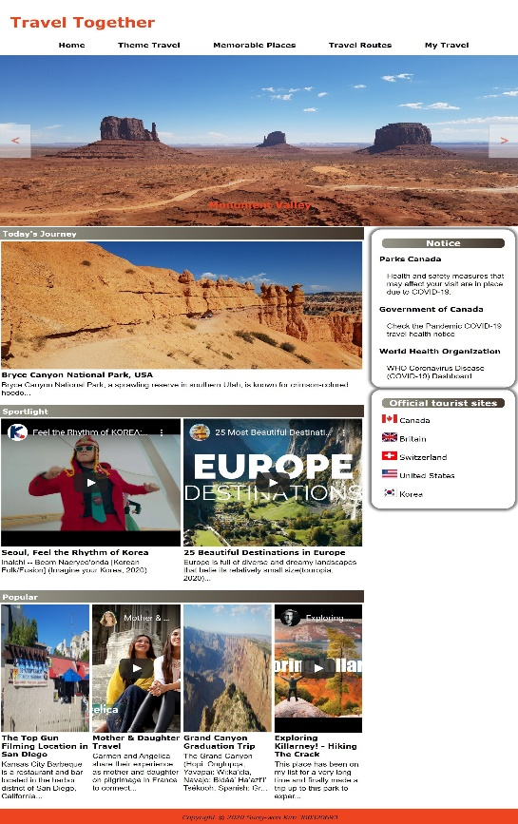 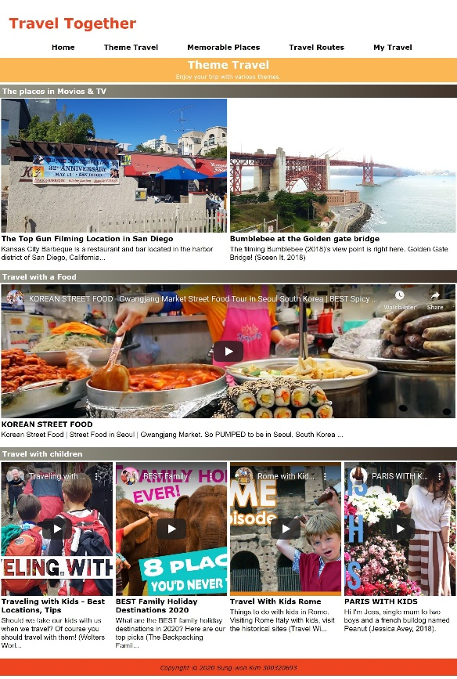

* + - **Tablet mode**

- Up to two columns can be variable in the main section.

- Unlike desktop mode, the main section in tablet mode can have up to two columns that can be variable, so that the content can be seen better by the user at a narrower screen resolution.

[Home] [Other menu]

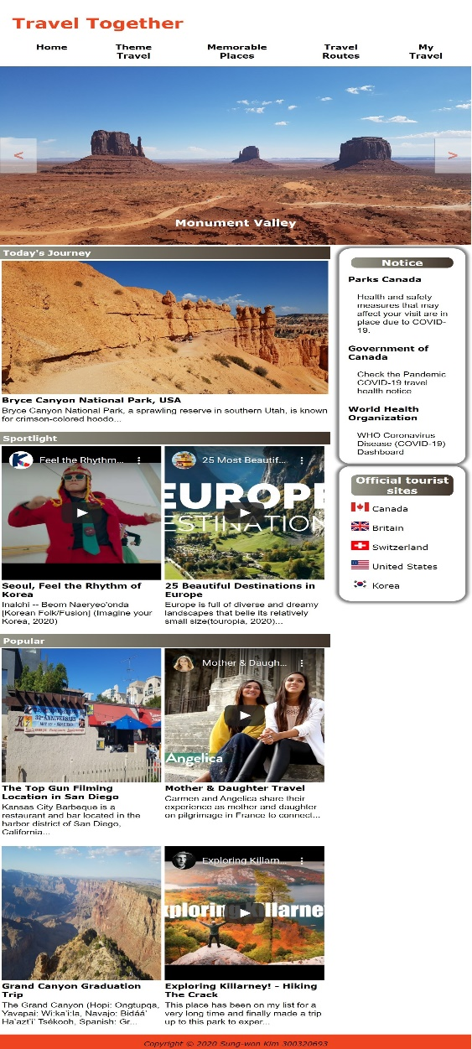 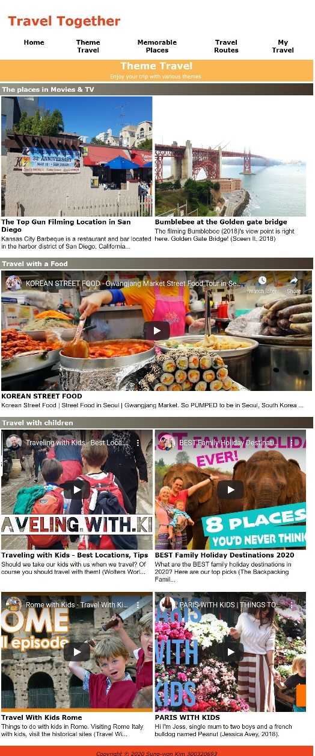

* + - **Mobile mode**

- Pages in mobile mode can have only one column.

[Home] [Other menu]

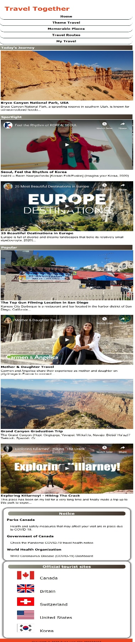 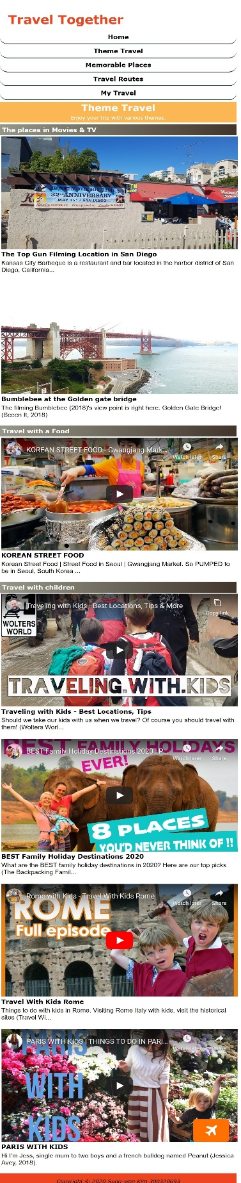

1. **Home - main features**
   * + Slide section on the top of the page
     + Display contents based on the data in the designated sections
     + Offering on travel precautions and information on official tourist sites
     + Dynamic columns (1~ 4 columns)
     + Click each content title to view details

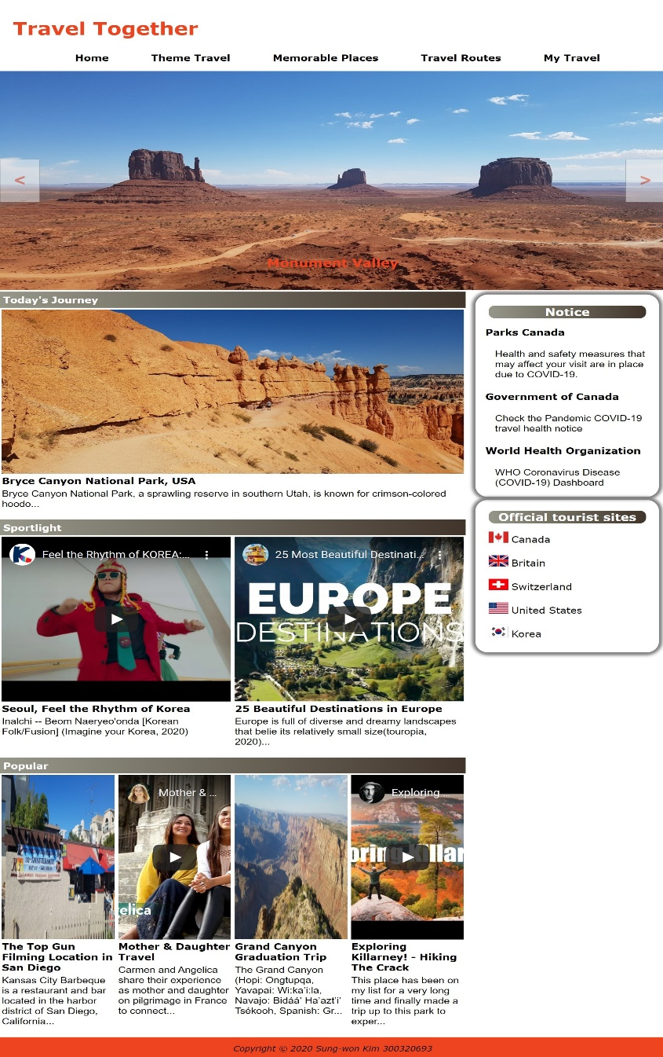

1. **Other menu - main features**

* Menu title area instead of slide section of the home
* Wider main section without Aside area
* Dynamic columns (1~ 4 columns)
* Click each content title to view details

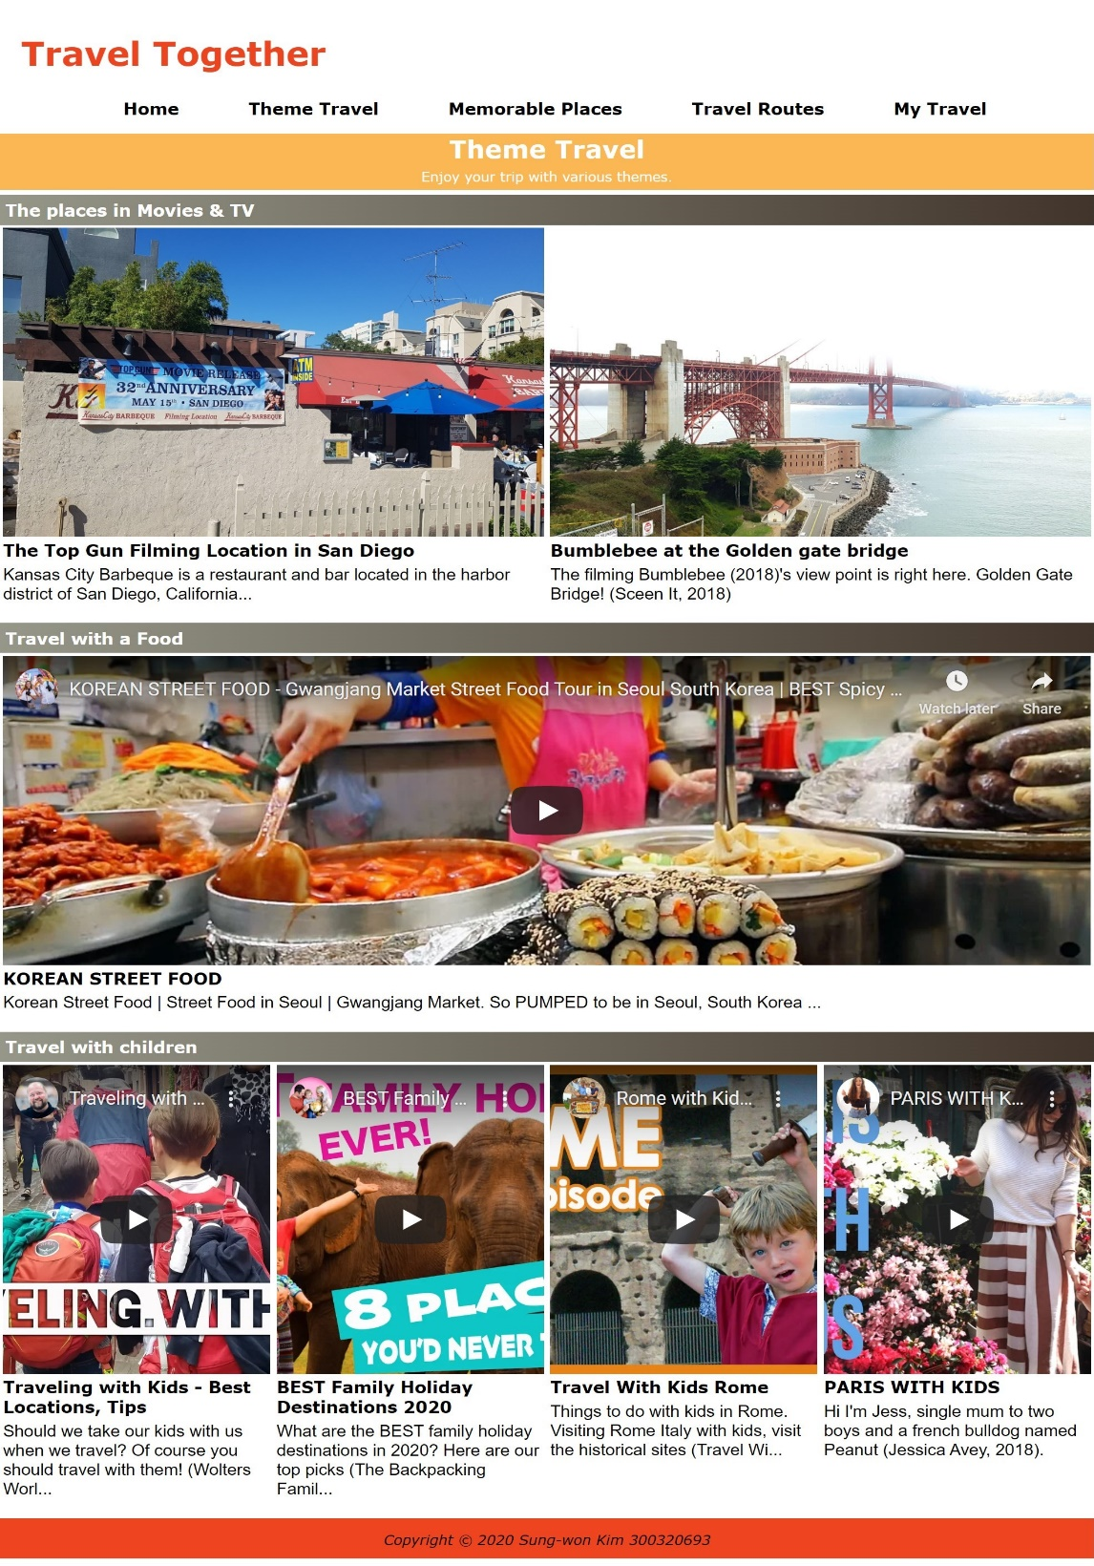

1. **Detail Page**
   * + Providing a wide viewing point of a single column
     + User comments can be added
     + Map provided through the connection of Google Maps API
     + Providing links related to the contents

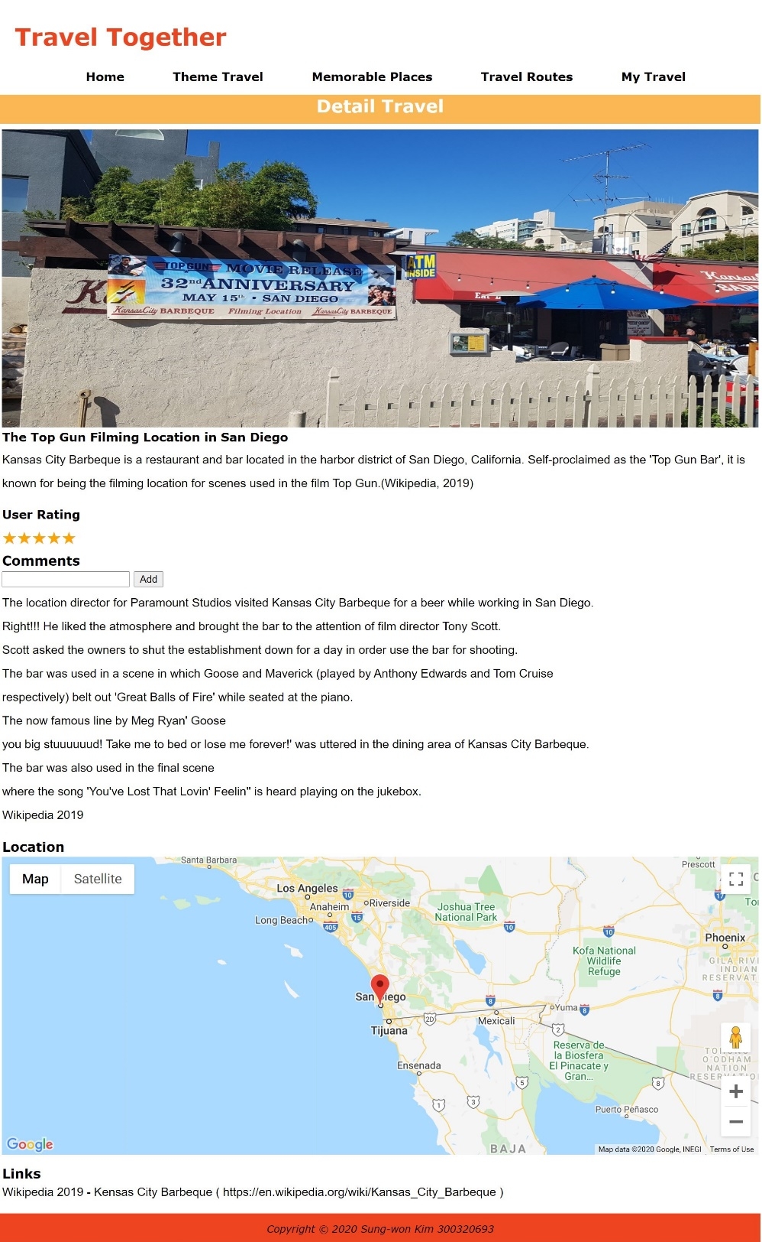

1. **My List**
   * + Add travel
       1. Provide input function, but do not store input data because this program has no back-end application. However, I hope that there will be an opportunity to implement storage function later through the connection with DB.

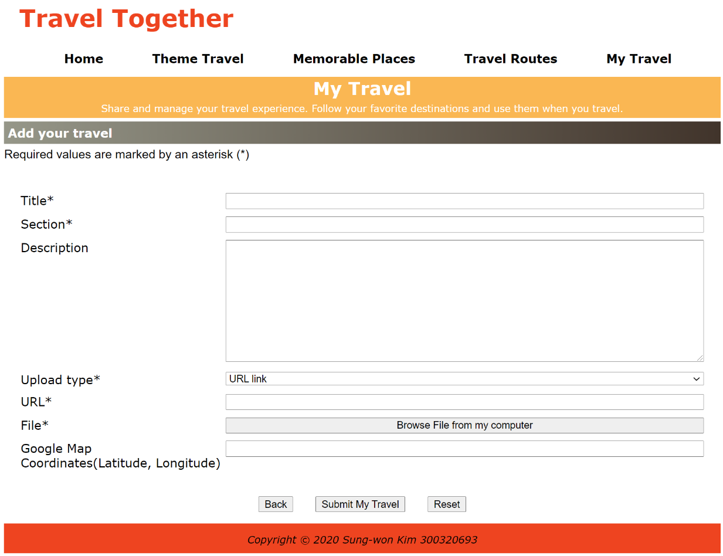

**6.References**

[Digital Image]

Britain Flag[Digital Image]. (2012). Retrieved from https://pixabay.com/vectors/union-jack-flag-union-flag-26119/

Canada Flag[Digital Image]. (2012). Retrieved from https://pixabay.com/vectors/canada-flag-canadian-symbol-27003/

Korea Flag[Digital Image]. (2012). Retrieved from https://pixabay.com/vectors/south-korea-flag-korean-national-32234/

Switzerland Flag[Digital Image]. (2012). Retrieved from https://pixabay.com/vectors/united-flag-states-america-26177/

United States Flag[Digital Image]. (2012). Retrieved from https://pixabay.com/vectors/switzerland-national-flag-nation-26891/

[Wikipedia]

Bryce Canyon. (2020). In Wikipedia. Retrieved November 28, 2020, from https://en.wikipedia.org/wiki/Bryce_Canyon_National_Park

Grand Canyon. (2020). In Wikipedia. Retrieved November 28, 2020, from https://en.wikipedia.org/wiki/Grand_Canyon

Interaken OST. (2020). In Wikipedia. Retrieved November 28, 2020, from https://en.wikipedia.org/wiki/Interlaken_Ost_railway_station

Kensas City Barbeque. (2019). In Wikipedia. Retrieved November 28, 2020, from https://en.wikipedia.org/wiki/Kansas_City_Barbeque

Niagara Falls. (2020). In Wikipedia. Retrieved November 28, 2020, from https://en.wikipedia.org/wiki/Niagara_Falls

Monument Valley. (2020). In Wikipedia. Retrieved November 28, 2020, from https://en.wikipedia.org/wiki/Monument_Valley

Universal Studios Hollywood. (2020). In Wikipedia. Retrieved November 28, 2020, from https://en.wikipedia.org/wiki/Universal_Studios_Hollywood

[Youtube]

Avey, J. [jessicaavey]. (2018, April 19). PARIS WITH KIDS | THINGS TO DO IN PARIS WITH CHILDREN | TRAVEL WITH KIDS [Video file]. Retrieved from https://www.youtube.com/watch?v=9WfA5BSnxj8&feature=youtu.be

Bicycle Touring Pro. (2017, Feburary 6). The Arctic Coast Cycling Tour - FULL MOVIE [Video file]. Retrieved from https://www.youtube.com/watch?v=yvR8P3G9mqE&feature=youtu.be

Bound For Nowhere. (2019, Jun 18). Top 5 | Hikes in the US and Canada [Video file]. Retrieved from https://www.youtube.com/watch?v=dr2j5U427FE&feature=youtu.be

Cheung, H. [henrycheung]. (2017, August 13). Cycling in Singapore: A 73km Scenery Route [Video file]. Retrieved from https://www.youtube.com/watch?v=eatQigHCmrY&feature=youtu.be

Henderson, M. [merita henderson]. (2020, January 1r). Same place different seasons [Video file]. Retrieved from https://www.youtube.com/watch?v=JGfLKtOkplU&feature=youtu.be

Hirlaender, N. [ninahirlaender]. (2016, August 11). Mothers & Daughter Travel [Video file]. Retrieved from https://www.youtube.com/watch?v=knvxFkvEE1M&feature=youtu.be

Imagine your Korea. (2020, July 29). Feel the Rhythm of KOREA: SEOUL [Video file]. Retrieved from https://www.youtube.com/watch?v=3P1CnWI62Ik&feature=youtu.be

Martin, L. [lukemartin]. (2017, September 18). KOREAN STREET FOOD - Gwangjang Market Street Food Tour in Seoul South Korea | BEST Spicy Korean Food [Video file]. Retrieved from https://www.youtube.com/watch?v=cVZheE7mNR4&feature=youtu.be

Sedran, D. [dan sedran].(2017, October 26). Exploring Killarney! - Hiking "The Crack" [Video file]. Retrieved from https://www.youtube.com/watch?v=HhILvf0xqFM&feature=youtu.be

Team WITW. (2018, January 9). Time travel to the past - Same place, same man, same gesture [Video file]. Retrieved from https://www.youtube.com/watch?v=9rEFg7-NYgk&feature=youtu.be

The Backpacking Family. (2018, Jun 3). BEST Family Holiday Destinations 2020 | Places to Travel with Family! (ideas others don't think of!) [Video file]. Retrieved from https://www.youtube.com/watch?v=yC2BYCPB40w&feature=youtu.be

Touropia. (2020, October 15). 25 Most Beautiful Destinations in Europe - Travel Video [Video file]. Retrieved from https://www.youtube.com/watch?v=7lvXbfNBIQg&feature=youtu.be

Travel With Kids TV. (2012, April 4). Rome with Kids - Travel With Kids Rome [Video file]. Retrieved from https://www.youtube.com/watch?v=iXo1ApC2R9E&feature=youtu.be

Wolters World. (2019, April 6). Traveling with Kids - Best Locations, Tips & More [Video file]. Retrieved from https://www.youtube.com/watch?v=f7aCwu_SjMo&feature=youtu.be

You Me & the RV. (2019, August 3). RV Trip Wizard - (BEST RV ROUTE PLANNER) - Full Time RV [Video file]. Retrieved from https://www.youtube.com/watch?v=03lUrlF0K3k&feature=youtu.be

[Website]

Sceen It. (2018). Golden gate bridge view point: Bumblebee 2018. Retrieved from https://www.sceen-it.com/sceen/2554/Bumblebee/Golden-Gate-Bridge-View-Point

Google. Google Maps Platform. (2020). Maps JavaScript API. Retrieved from https://developers.google.com/maps/documentation/javascript/markers#maps_marker_simple-javascript